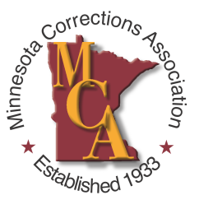
Call for Nominations: MCA Annual Awards

MCA is currently accepting nominations for the 2023 MCA Awards. If you would like to nominate a corrections person who has achieved distinction in their career, demonstrated outstanding leadership, or has shown exceptional volunteer services in their community – we welcome you to submit their name for consideration by completing the form below. As part of your nomination, we ask for a statement (500 words or less) on Page 2.

Deadline: July 31, 2023
Contact Jane Schmid, MCA Past President for Questions & Nomination Form Submission:
jane.schmid@co.brown.mn.us

Nominee’s contact information

Name:

Email:

Mailing Address:
(Street address, city, state, zip code)

Cell phone:

- Please share your connection to the individual to whom you are nominating (100 words or less).

- Describe nominee’s current career or leadership roles, honors, awards, and publications. You may attach additional details etc. (250 words or less).

- Discuss Nominee’s Community Leadership and Involvement (Committee Service, community service or volunteering).

- Give examples of outstanding character such as overcoming adversity, representing a group previously underrepresented in their field, significant mentoring and support to others.
Nominator’s contact information
Name:

Email: Cell phone:

Mailing Address:
(Street address, city, state, zip code)

Awards:

- Corrections Person of the Year
- Corrections Officer of the Year
- President’s Award
- Technology Award
- Professional Achievement Award:
Correctional Facility
- Professional Achievement Award
Field Services
- Board of Directors’ Award

Statement – 500 words or less about the nominee

