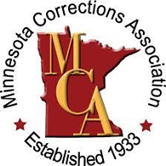 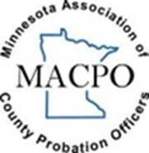 5th Annual Juvenile Justice Conference
Forging Our Future: Keeping the Focus on Today’s Youth
Thursday, April 18, 2024 Maplewood Community Center

9:00 – 9:15 AM: Welcome
Carter Diers, MCA President
Jon Schiro, MACPO President
Paul Schnell, Commissioner of Corrections

9:15 – 10:30 AM: Working with Juveniles who Sexually Offend
TinaMarie Hubbell, Village Ranch Child & Family Services

10:30 – 10:45 AM: Break/Resource Time – Sponsor Spotlight

10:45 – 12:00 PM: Addressing Clients with Mental Illness and Behavioral Difficulties
Frank Weber, Clinical Director CORE Professional Services

12:00– 12:45 PM: Lunch – Sponsor Spotlights

12:45 – 2:00 PM: DRT Changes Panel
Melissa McCann, Corrections Program Director MCF-Red Wing
Matt Bauer, Deputy Director of Facilities for Dakota County Community Corrections
Becky Pogatchnik, Superintendent Arrowhead Juvenile Center
Mindy O’Brien, Superintendent Northwestern MN Juvenile Center

2:00 – 2:15 PM: Break/Resource Time – Sponsor Spotlight

2:15 – 3:30 PM: Juvenile Competency Attainment in MN
Elliot Butay, Senior Policy Coordinator, NAMI Minnesota
Tracy Reid, Asst Public Defender, Hennepin County, Juvenile Division

Thank you to our Event Sponsors!

Diamond Platinum Gold

Lakeside Academy – MNATC Al-Maa’uun West Central Regional Juvenile Center
Prairie Lakes Youth Programs Damascus Way
180 Degrees Village Ranch

